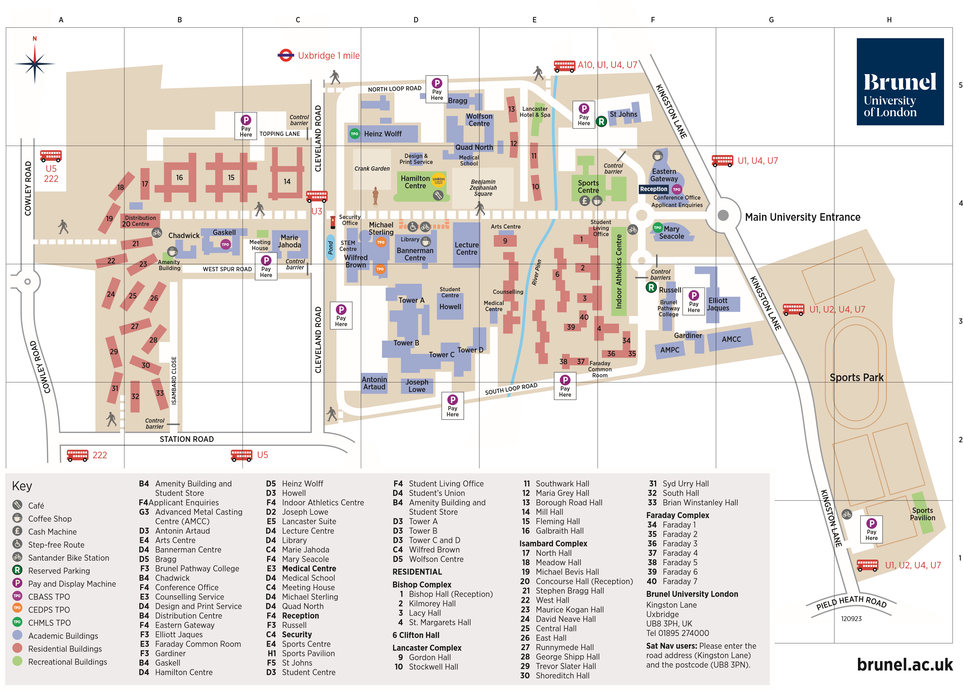
Getting to Brunel University London

BY BUS
From Heathrow Central: A10 “Heathrow Fast”, every 15 minutes, (alight Hillingdon Rd at ‘The Greenway’ and use footpath to campus).
From Stockley Park: A10 “Heathrow Fast” as above.
From West Drayton railway station:
U3 (alight Cleveland Road)
U1 (alight Kingston Lane)
222 (alight Cowley Road and use path to campus).
From Uxbridge (underground) station:
U3 (alight Cleveland Road)
U1, U4 and U7 (alight Kingston Lane)
222 and U5 (alight Cowley Road and use footpath to campus).

BY UNDERGROUND
Uxbridge Station (Transport for London) take the Metropolitan Line from central
London (and Piccadilly Line during peak hours). Then take a taxi, or bus U1, U3, U4 or U7. (Alternatively there is a 1 mile walking route.)

BY RAIL
West Drayton (First Great Western Link) is the nearest main-line station (approx 1.5 miles from the campus). Services from London Paddington or the West
(Bristol). From West Drayton station take a bus towards Uxbridge: 222 (alight Cowley Road), U5 (alight Station Road), U3 (alight Cleveland Road) or U1 (alight Kingston Lane).
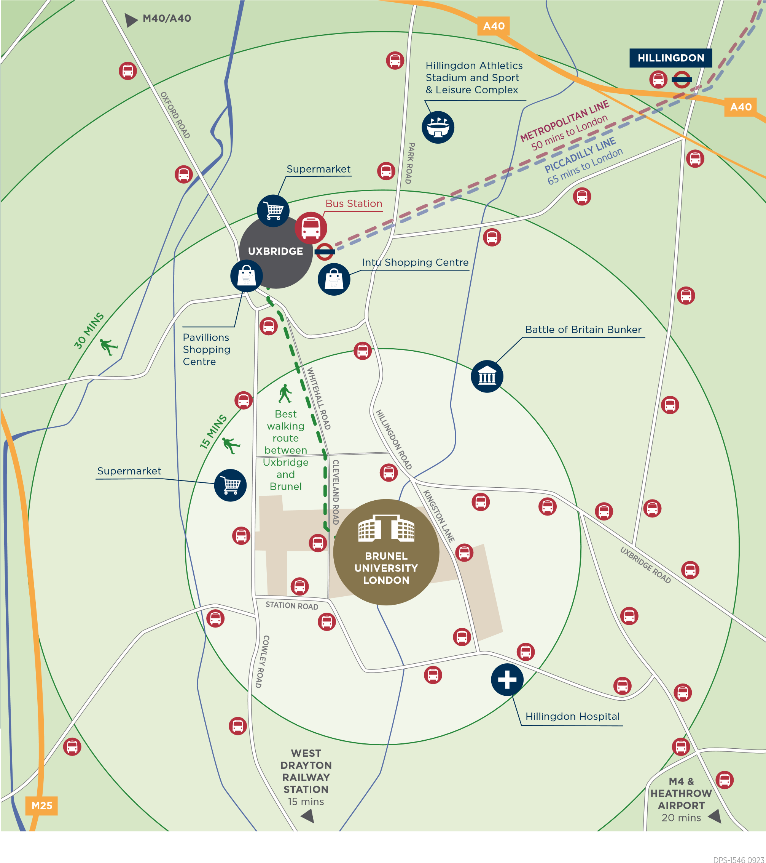
West Ruislip Station (Chiltern Railways) is the main-line service from London Marylebone and the North (Aylesbury, Banbury and Birmingham) and is approximately 4 miles from the campus. From West Ruislip Station take the U1 bus towards West Drayton, alight Kingston Lane.

BY ROAD
Entry by car is via Kingston Lane only. Sat Nav users: Please enter the road address (Kingston Lane) and the postcode (UB8 3PN). You will be directed to Kingston Lane, which is very close to our main entrance. From there, please follow the signs.
Parking on the Uxbridge Campus and in the local area is very restricted. Barriers control access to the site and all vehicles must display a valid permit. On arrival, pay-and-display parking is available. In addition, parking may also be pre-booked (restrictions apply).
Parking Charge Notices will be issued for illegally parked vehicles and vehicles not registered for a Brunel Virtual permit. If not registered for a Brunel Virtual permit all vehicles must use the Pay & Display.

VISITOR PARKING FOR DISABLED BLUE BADGE HOLDERS
Accessible parking bays are available at various locations around campus. Please register for a virtual permit with the Main Reception in the Eastern Gateway Building and display your Blue Badge..

